**SEE**

by

|  |  |  |
| --- | --- | --- |
| Student Names | Student ID | Department |
| **Ziad Tahoun** | **215123** | **AI** |
| **Ahmed Reda** | **215125** | **AI** |
| **Hager Essa** | **215128** | **AI** |
| **Ahmed Azazy** | **215149** | **AI** |
| **Omar Ayman** | **215184** | **AI** |
| **Mariam sami** | **215188** | **AI** |

**Supervised by**

**Dr. Sameh Zarif**

**Degree Program**

**Artificial Intelligence**

### **[Egyptian Russian University](https://eru.edu.eg/)**

**2025**

# Declaration

We, the undersigned, hereby declare that the work presented in this report titled SEE is the result of our collective efforts and original research. The project was carried out under the supervision of Sameh Zarif in partial fulfillment of the requirements for the degree of Artificial Intelligence. We confirm that this work has not been submitted elsewhere for any degree or qualification and that it complies with the ethical and academic standards of ERU.

|  |  |  |  |  |
| --- | --- | --- | --- | --- |
| Student Names | Student ID | Department | Signatures | date |
| **Ziad Tahoun** | **215123** |  |  |  |
| **Ahmed Reda** | **215125** |  |  |  |
| **Hager Essa** | **215128** |  |  |  |
| **Ahmed Azazy** | **215149** |  |  |  |
| **Omar Ayman** | **215184** |  |  |  |
| **Mariam sami** | **215188** |  |  |  |

# Acknowledgements

All gratitude and thanks must be firstly given to “ALLAH” who guides me throughout the whole of my life and for his merciful support and guidance to complete this work.

I would like to express my deep appreciation and gratitude to my supervisor Dr. Sameh Zarif and Eng. Waleed.

Special thanks to my father, mother, sister and brother without their support and prayers, I could not be where I am now. I am ever grateful for their love and trust in my judgment, which opened the door to my education.

Table of Contents

**Egyptian Russian University** i

Declaration ii

Acknowledgements iii

1. CHAPTER 1 INTRODUCTION 1

1.1 Overview 1

1.2 Problem Description 1

1.3 Project Motivation 2

1.4 Project Objectives. 3

2. CHAPTER 2 RELATED WORK 2-- 5 -

2.1 Literature Review 2-- 5 -

3. CHAPTER 3 PROJECT ANALYSIS 3-- 9 -

3.1 Problem Statement 3-- 9 -

3.2 Problem Analysis 3-- 10 -

3.3 Project Feasibility Study 3-- 11 -

3.4 Project Time Scheduling 3-- 12 -

3.5 Functional Requirements 3-- 13 -

3.6 Non-Functional Requirements 3-- 14 -

3.7 Use Case Diagram 3-- 15 -

3.8 Use case scenario 3-- 16 -

3.9 Activity Diagram 3-- 17 -

3.10 Entity Relationship Diagram 3-- 18 -

3.11 Class diagram 3-- 19 -

3.12 Sequence diagram 3-- 20 -

4. Chapter 4 PROJECT DESIGN 22

List of Figures

Figure 1Use Case Diagram 3-- 8 -

Figure 2 Use Case Scenario 3-- 9 -

Figure 3 Activity Diagram 3-- 10 -

Figure 4 Entity Relationship Diagram 3-- 11 -

Figure 5 Class Diagram 3-- 12 -

Figure 6 Sequence Diagram 3-- 13 -

Figure 7 System Architecture and the Agile project plan 15

Figure 8 Multiple Screens' Designs 17

Figure 9 Hardware Gadget 19

Figure 10 Skills Page 20

Figure 11 A code snippet for creating the skill cards. 20

List of Abbreviations

* **AI** - Artificial Intelligence
* **CNN** - Convolutional Neural Network
* **FPGA** - Field-Programmable Gate Array
* **VGA** - Video Graphics Array
* **OV7670** - A model of camera sensor
* **KNN** - K-Nearest Neighbors
* **API** - Application Programming Interface
* **URL** - Uniform Resource Locator
* **NLP** - Natural Language Processing
* **API** - Application Programming Interface
* **UI** - User Interface
* **UX** - User Experience
* **RAM** - Random Access Memory
* **CPU** - Central Processing Unit
* **GPU** - Graphics Processing Unit
* **ML** - Machine Learning
* **IoT** - Internet of Things
* **NIST** - National Institute of Standards and Technology
* **IEEE** - Institute of Electrical and Electronics Engineers
* **DL** - Deep Learning

**ABSTRACT**

The SEE project aims to develop an integrated system combining a wearable device and a mobile application to support children with Down syndrome in managing emotions and enhancing social and cognitive skills. Emotional regulation is a critical challenge for children with Down syndrome, significantly impacting their developmental outcomes and quality of life. The wearable device monitors emotional states such as fear, joy, and anxiety, using advanced AI algorithms to analyze physiological and behavioral data. Based on these analyses, the system provides real-time, adaptive feedback, including calming audio and visual prompts, to help children navigate emotional challenges. The mobile application serves as a comprehensive platform for parents and specialists, enabling them to track the child’s progress through detailed reports and visualizations. It also offers tools to customize therapy plans and facilitate collaboration between caregivers and professionals, ensuring personalized and effective interventions. By leveraging AI and wearable technology, the SEE project explores a novel approach to improving developmental outcomes for children with Down syndrome, setting the stage for future advancements in personalized therapy solutions.

# CHAPTER 1 INTRODUCTION

* 1. Overview

The SEE system is designed to assist parents of children with Down syndrome by providing real-time emotion detection and developmental support through an integrated wearable gadget and mobile app. The system will monitor the child's emotional state and provide immediate feedback to parents, helping them respond effectively to their child's needs. Children with Down syndrome often face challenges in expressing and managing their emotions, which can lead to difficulties in social interactions and emotional regulation. The SEE system aims to address these challenges by offering a comprehensive solution that combines advanced AI technologies with user-friendly interfaces.

The wearable gadget, equipped with emotion-detecting sensors, will continuously monitor the child's emotional state and send real-time data to the mobile app. The app will analyze this data and provide parents with actionable insights, such as suggestions for calming techniques or activities tailored to the child's emotional needs. By offering real-time feedback and personalized support, the SEE system aims to enhance the emotional well-being and overall development of children with Down syndrome.

* 1. Problem Description

Parents of children with Down syndrome often face significant challenges in understanding and responding to their child's emotional needs. Children with Down syndrome may experience difficulties in expressing their emotions clearly, which can make it challenging for parents to provide appropriate support in real-time. Additionally, these children may have unique emotional and developmental needs that are not adequately addressed by existing tools and technologies.

Current tools for emotional monitoring are often either too complex or not tailored to the specific needs of children with Down syndrome. Many of these tools rely on manual inputs from caregivers, which can be time-consuming and prone to errors. Furthermore, existing systems often lack real-time feedback mechanisms, making it difficult for parents to respond promptly to their child's emotional state.

The SEE system aims to address these challenges by offering a simple, real-time solution that combines wearable technology with a mobile app. By providing parents with immediate insights into their child's emotional state, the SEE system will empower them to respond effectively and support their child's emotional and developmental needs.

* 1. Project Motivation

The motivation behind this project is to empower parents with a tool that allows them to better understand and respond to their child's emotional needs. Emotional well-being is critical for the overall development of children with Down syndrome, and having immediate insights into their emotions can significantly improve their quality of life.

Children with Down syndrome often face unique challenges in emotional regulation and social interactions. These challenges can lead to frustration, anxiety, and difficulties in forming meaningful relationships. By providing parents with real-time feedback and personalized suggestions, the SEE system aims to enhance the emotional well-being of these children and strengthen parent-child interactions.

Moreover, the SEE system seeks to bridge the gap between technology and personalized care for children with Down syndrome. By leveraging advanced AI technologies and wearable devices, the project aims to create a holistic support system that addresses the unique emotional and developmental needs of these children. The ultimate goal is to improve the quality of life for children with Down syndrome and their families by providing them with the tools and resources they need to thrive.

* 1. Project Objectives.

The primary objectives of the **SEE** system include:

1. **Real-Time Emotion Detection:** Develop a system that can detect emotional changes in real-time using advanced AI models and wearable technology. The system will monitor the child's emotional state and provide immediate feedback to parents.
2. **Mobile App Integration:** Create a mobile app that receives real-time emotion data from the wearable gadget and provides alerts and suggestions to parents. The app will offer personalized recommendations for managing the child's emotional state and tracking their progress over time.
3. **User-Friendly Interface:** Ensure that the system is user-friendly and accessible to parents with varying levels of technical expertise. The mobile app will feature an intuitive interface with clear visualizations of the child's emotional data and progress.
4. **Reliability and Performance:** Design a system that is reliable, efficient, and capable of providing immediate assistance to parents. The system will be optimized for high performance with minimal latency, ensuring that parents receive timely feedback and support.
5. **Scalability and Future Expansion:** Build a scalable system that can accommodate additional features and functionalities in the future. The system will be designed to support a growing user base and integrate new technologies as they become available.

By achieving these objectives, the **SEE** system aims to provide a comprehensive solution for supporting the emotional and developmental needs of children with Down syndrome. The project will demonstrate the potential of AI and wearable technology to improve outcomes for these children and their families.

# CHAPTER 2 RELATED WORK

1. 1. Literature Review

**Scope of Review**

Advancements in wearable technology and artificial intelligence (AI) have significantly enhanced therapeutic interventions for children with Down syndrome, particularly in emotional regulation and cognitive development. This section reviews current literature on the application of these technologies in supporting children with Down syndrome.

**Grouping the Literature**

**1. Wearable Devices for Emotional Regulation**

Emotion detection using AI and machine learning has seen significant advancements in recent years. Researchers have focused on using facial recognition, voice analysis, and wearable sensors to identify emotional states. This is particularly important for applications involving children with developmental disabilities like Down syndrome, where emotional expression may be limited or atypical.

**Study 1 Talkitt: Toward a New Instrument Based on Artificial Intelligence for Augmentative and Alternative Communication in Children with Down Syndrome.**

* **Goal**: To design a wearable device that supports communication and emotional expression in children with Down syndrome using AI-based speech recognition.
* **Methodology**: Development of the Talkitt device, which translates non-standard speech patterns into intelligible speech, utilizing AI algorithms for speech recognition and processing.
* **Key Findings**: The Talkitt device significantly enhanced communication abilities in children with Down syndrome, facilitating better expression of emotions and needs.
* **Strengths**: The device improves speech communication and emotional regulation without requiring extensive caregiver intervention.
* **Limitations**: The system may require adjustments for children with highly non-standard speech patterns, and its generalizability is yet to be fully established.

**2. AI Applications in Therapy**

Wearable devices have been explored as a means of enhancing child safety and emotional well-being. These devices can monitor various physiological signals that indicate emotional or health changes, providing parents with valuable insights.

**Study 3:** FDNA™ - AI Image Analysis for Developmental and Genetic Disorders.

* **Goal**: To demonstrate the potential of AI technologies in the early detection of developmental delays in children with genetic conditions, including Down syndrome.
* **Methodology**: FDNA™ analyzes facial features using AI to identify markers indicative of developmental or genetic disorders.
* **Key Findings**: The AI tool exhibits high accuracy in identifying early signs of developmental delays, facilitating timely interventions. It is non-invasive and relatively user-friendly.
* **Strengths**: Non-invasive and scalable with high diagnostic accuracy, it provides an efficient method for early intervention planning.
* **Limitations**: The effectiveness depends on the quality of images provided and may require supplementary diagnostic measures.

**3. Testing the Performance of Face Recognition for People with Down Syndrome**

Mobile applications tailored for children with Down syndrome aim to enhance learning, social skills, and emotional regulation. These apps can integrate emotional feedback, supporting both the child and the caregiver.

**Study 4:** Mobile Apps for Children with Down Syndrome (Hernandez et al., 2021)

* **Goal** To explore AI-powered facial recognition as a tool for personalized therapy and identification of behavioral patterns in children with Down syndrome.
* **Methodology**: Facial recognition technology was applied to analyze emotional and physical states, enabling tailored interventions.
* **Key Findings**: Enhanced recognition accuracy led to more personalized therapeutic approaches. However, scalability remains a challenge due to technical requirements.
* **Strengths**: Facilitates personalized and adaptive therapeutic strategies, enhancing effectiveness for individual users.
* **Limitations**: Limited sample size and reliance on advanced equipment.

**Research Gap**

The integration of wearable devices and AI technologies into therapeutic frameworks has shown substantial potential for improving the lives of children with Down syndrome. These innovations enable personalized, real-time interventions that address emotional, communicative, and cognitive challenges, providing targeted solutions that empower caregivers and foster independence in children. Despite these promising developments, challenges remain. Many technologies require further validation through large-scale studies to establish their efficacy and long-term impact. Accessibility is another critical area, as specialized equipment and software may not be readily available to all families or institutions. Moreover, ensuring that these technologies are adaptable to the diverse needs of children with Down syndrome is essential for their broader application. Future research should prioritize creating cost-effective, scalable solutions that maintain high efficacy while fostering collaboration between technologists, healthcare providers, and educators. Addressing these challenges will unlock the full potential of wearable and AI technologies to revolutionize therapeutic care for children with Down syndrome, paving the way for more inclusive and effective interventions.

# CHAPTER 3 PROJECT ANALYSIS

1. 1. Problem Statement

Parents of children with Down syndrome often face significant challenges in understanding and responding to their child's emotional needs. Children with Down syndrome may experience difficulties in expressing their emotions clearly, which can make it challenging for parents to provide appropriate support in real-time. Additionally, these children may have unique emotional and developmental needs that are not adequately addressed by existing tools and technologies.

Current tools for emotional monitoring are often either too complex or not tailored to the specific needs of children with Down syndrome. Many of these tools rely on manual inputs from caregivers, which can be time-consuming and prone to errors. Furthermore, existing systems often lack real-time feedback mechanisms, making it difficult for parents to respond promptly to their child's emotional state.

The SEE system aims to address these challenges by offering a simple, real-time solution that combines wearable technology with a mobile app. By providing parents with immediate insights into their child's emotional state, the SEE system will empower them to respond effectively and support their child's emotional and developmental needs.

* 1. Problem Analysis

The lack of accessible, easy-to-use tools to monitor and respond to the emotional needs of children with Down syndrome presents a significant challenge for families. Children with Down syndrome often experience difficulties in emotional regulation, which can lead to frustration, anxiety, and difficulties in social interactions. These challenges can have a profound impact on the child's overall development and quality of life.

Existing tools for emotional monitoring are often not designed with the unique needs of children with Down syndrome in mind. Many of these tools are either too complex for parents to use effectively or do not provide real-time feedback, making it difficult for parents to respond promptly to their child's emotional state. Additionally, there is a lack of integration between emotion detection technologies, wearable devices, and mobile applications, which limits the effectiveness of these tools.

The SEE system aims to address these gaps by providing a comprehensive solution that combines real-time emotion detection with a user-friendly mobile app. The system will monitor the child's emotional state using wearable technology and provide parents with immediate feedback and personalized suggestions for managing their child's emotional needs. By offering a simple, real-time solution, the SEE system will empower parents to respond effectively to their child's emotional needs and support their overall development.

* 1. Project Feasibility Study

The feasibility of the **SEE** system has been evaluated based on several factors, including technical feasibility, resource availability, and alignment with project goals. The following points outline the feasibility of the project:

1. **Technical Feasibility:** The technologies required for the **SEE** system, such as emotion detection algorithms, wearable sensors, and mobile app development frameworks, are well-established and widely available. The use of AI models for emotion recognition and the integration of wearable technology with a mobile app are technically achievable with existing tools and platforms.
2. **Resource Availability:** The project team has access to the necessary resources, including software development tools, AI frameworks, and hardware components for prototyping. Additionally, the team has the required expertise in AI, software development, and user interface design to successfully execute the project.
3. **Alignment with Project Goals:** The **SEE** system aligns with the project's goals of providing real-time emotional support for children with Down syndrome and empowering parents with actionable insights. The system's design focuses on simplicity, accessibility, and real-time feedback, which are key requirements for addressing the challenges faced by parents of children with Down syndrome.
4. **Budget and Time Constraints:** The project has been planned with a realistic budget and timeline, taking into account the costs of hardware components, software development, and testing. The project will be completed in several phases, with each phase focusing on specific deliverables and milestones.
   1. Project Time Scheduling

The project will be completed in several phases, each with specific deliverables and milestones. The following is a high-level overview of the project timeline:

* **Phase 1: Design and Prototyping (2 months)**
  + Conduct a detailed requirements analysis.
  + Design the system architecture and user interface.
  + Develop a prototype of the wearable gadget and mobile app.
* **Phase 2: Implementation and Integration (3 months)**
  + Implement the emotion detection algorithms and integrate them with the wearable gadget.
  + Develop the mobile app and integrate it with the wearable gadget.
  + Conduct initial testing to ensure the system components work together seamlessly.
* **Phase 3: Testing and Optimization (2 months)**
  + Conduct extensive testing to identify and fix any issues.
  + Optimize the system for performance, reliability, and user experience.
  + Prepare the final deliverables and documentation.

This timeline ensures that the project is completed on schedule and that each phase is given adequate time for development and testing.

* 1. Functional Requirements

1. **Real-Time Emotion Detection:** The system must be able to detect the child's emotional state in real-time using wearable technology and AI models. The system should be able to classify emotions such as happiness, sadness, anger, and anxiety with a high degree of accuracy.
2. **Mobile App Integration:** The system must include a mobile app that receives real-time emotion data from the wearable gadget and provides alerts and suggestions to parents. The app should offer personalized recommendations for managing the child's emotional state and tracking their progress over time.
3. **User-Friendly Interface:** The mobile app must have an intuitive and user-friendly interface that is easy for parents to navigate. The app should provide clear visualizations of the child's emotional data and progress, as well as easy access to features such as alerts and suggestions.
4. **Data Security and Privacy:** The system must ensure that all data collected from the wearable gadget and mobile app is securely stored and transmitted. The system must comply with data privacy regulations and protect the sensitive information of users.
5. **Scalability:** The system must be designed to accommodate additional features and functionalities in the future. The system should be scalable to support a growing user base and integrate new technologies as they become available.
   1. Non-Functional Requirements
6. **Performance:** The system must provide real-time feedback with minimal latency. The emotion detection algorithms must be optimized for high performance, and the mobile app must respond quickly to user inputs.
7. **Reliability:** The system must be reliable and capable of operating continuously without significant downtime. The wearable gadget and mobile app must be designed to handle errors and recover gracefully from failures.
8. **Usability:** The system must be easy to use for parents with varying levels of technical expertise. The mobile app must have a simple and intuitive interface, with clear instructions and visualizations.
9. **Accessibility:** The system must be accessible to users with disabilities, including parents and children with Down syndrome. The mobile app must support features such as high-contrast color schemes, large buttons, and readable fonts.
10. **Maintainability:** The system must be designed for easy maintenance and updates. The codebase must be well-documented, and the system must be modular to allow for future enhancements.
    1. Use Case Diagram

Figure 1Use Case Diagram

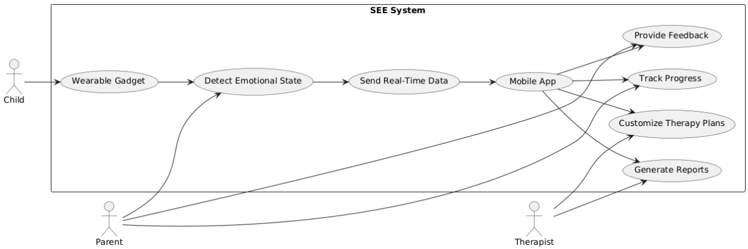

The system includes key use cases such as:

* A parent receiving a notification about their child’s emotional state.
* A child wearing the gadget and having their emotional state detected in real time.
* The app providing advice on how to respond to the child’s emotional needs.

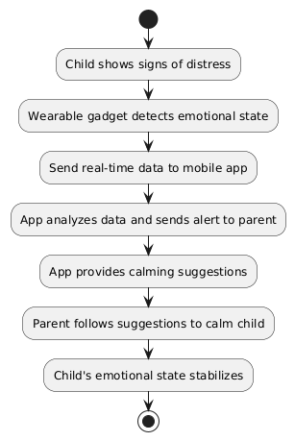

Figure 2 Use Case Scenario

Use case scenario

Scenario 1: A child shows signs of distress. The wearable gadget detects the change in emotional state and sends an alert to the parent’s mobile app. The app provides suggestions for calming techniques and notifies the parent of the child’s location.

* 1. 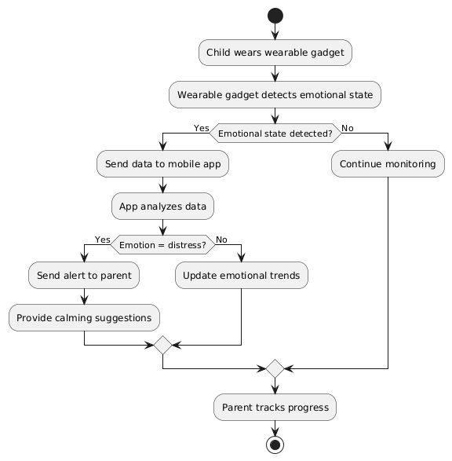Activity Diagram

The Activity Diagram for the SEE system shows the flow of activities that take place when the wearable gadget interacts with the mobile app. It outlines the key steps, such as detecting the child’s emotional state using AI sensors, processing that data to provide real-time feedback, and generating distress alerts if needed. The diagram also illustrates the interactions between the wearable and the app, including the steps for activity recommendations, progress tracking, and feedback sharing between parents, therapists, and the system.

Figure 3 Activity Diagram

* 1. Entity Relationship Diagram

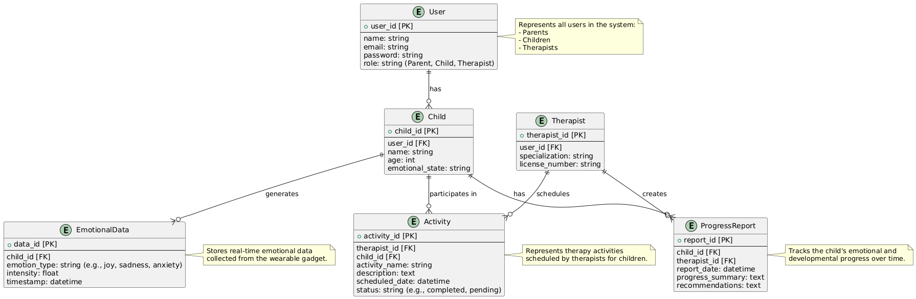

Figure 4 Entity Relationship Diagram

The Entity Relationship Diagram (ERD) for the SEE system shows how different entities within the system relate to each other. Key entities include the User (which can be a parent, child, or therapist), Emotional Data (collected from the wearable gadget), Progress Reports, and Activity Recommendations. The diagram highlights the relationships between these entities, such as how a user (e.g., parent or therapist) interacts with the child’s emotional data, monitors progress, and uses activity recommendations to guide development. It also illustrates the data flow between these entities within the system.

* 1. Class diagram

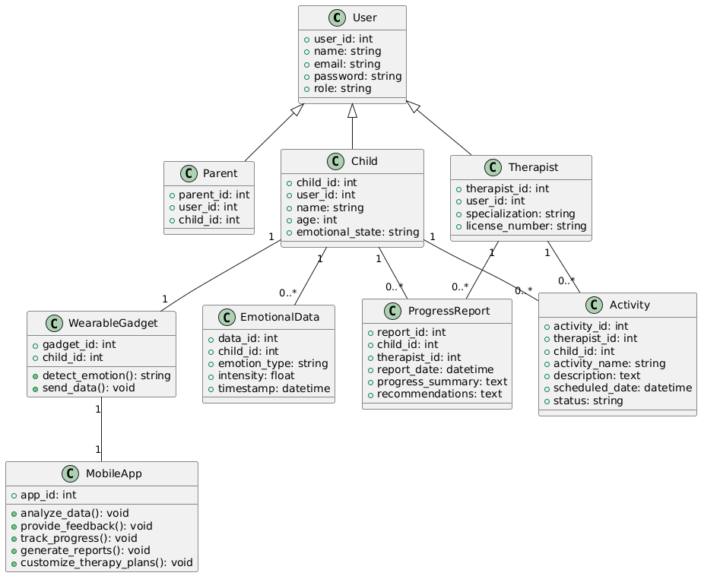

Figure 5 Class Diagram

The Class Diagram for the SEE system details the various classes (or objects) within the system and how they interact. Key classes include User (with subclasses for Parent, Child, and Therapist), Wearable Device (for detecting emotions and location), Mobile App (for processing and providing feedback), and Activity (for personalized tasks). The diagram defines the attributes (e.g., user details, emotional states) and methods (e.g., detect emotion, provide feedback) for each class, showing how objects are instantiated, communicate, and work together to deliver a seamless experience for the users.

* 1. Sequence diagram

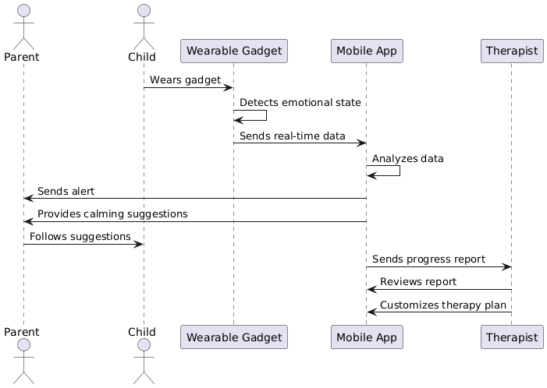

Figure 6 Sequence Diagram

The Sequence Diagram for the SEE system represents the sequence of interactions between the user (parent, therapist, child), the mobile app, and the wearable gadget. It shows the timeline of events, starting from the child’s emotional state being detected by the wearable, the app processing this data, and then providing the user (parent or therapist) with real-time feedback. It also includes the steps for tracking progress, sending distress alerts, and updating reports. This diagram helps visualize the order of operations and the communication flow between system components.

# Chapter 4 PROJECT DESIGN



**UI/UX design**

**a. Overview of the Design**

* The design of the SEE system focuses on creating a seamless and supportive experience for both children with Down syndrome and their parents. The goal is to deliver an intuitive, easy-to-use interface for the mobile app while ensuring the wearable gadget is comfortable, non-invasive, and offers real-time emotional feedback. The design takes into account the diverse needs of users, including accessibility, ease of navigation, and clear communication of emotional data and progress.

**b. System Architecture**

The SEE system consists of two main components: **the wearable gadget** and **the mobile application**. **The wearable gadget** detects emotional states and sends real-time data (including location and distress alerts) to the mobile app**. The app** provides **feedback**, **tracks progress**, and **facilitates communication** between **parents** and **specialists**.

Below is the system's architecture:

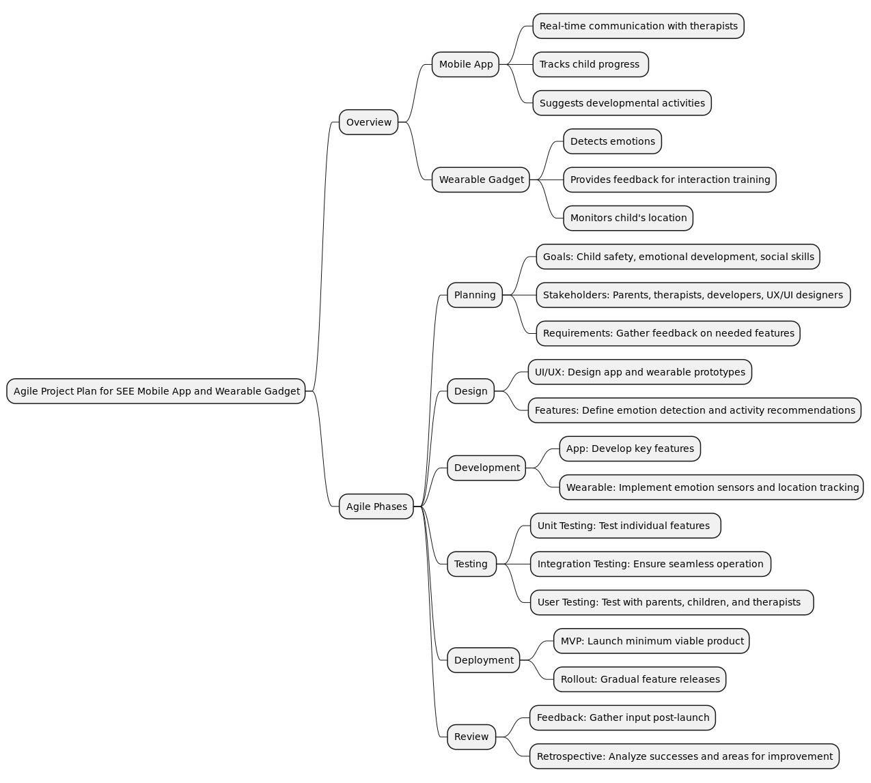

Figure 7 System Architecture and the Agile project plan

* **Components and their Roles:**
  + **Wearable Gadget:** Collects data on emotions, sends alerts and feedback to the mobile app.
  + **Mobile App:** Displays real-time data, tracks progress, provides therapy activities, and allows communication with specialists.
  + Parent and Specialist Interfaces: Parents monitor the child’s emotional state, progress, and therapy activities; specialists review the data and provide recommendations

.**c. Design Methodology**

1. **Wearable Gadget:**

* **Purpose**: Detect emotional states, track location, and send real-time alerts.
* **Inputs/Outputs:**
* **Inputs**: Emotional data (via AI sensors), user location.
* **Outputs**: Real-time location, emotional state data, distress alerts.
* **Design Details:**
  + AI-driven sensors.
  + Bluetooth for communication with the mobile app.
  + Embedded microcontroller to process emotional data.

1. **Mobile Application**

* **Purpose**: Provide feedback, track progress, and facilitate communication between parents and specialists.
* **Inputs/Outputs:**
* **Inputs**: Data from wearable gadget, user inputs (e.g., goals, preferences).
* **Outputs**: Emotional feedback, progress reports, activity recommendations.
* **Design Details:**
  + Cross-platform mobile app (iOS/Android).
  + Data visualization for emotional trends and therapy progress.
  + Communication interface for parent-specialist interaction.

**e. User Interface (UI) and User Experience (UX) Design**

The UI/UX design of the SEE app focuses on simplicity and clarity. The layout is designed to be intuitive, with easy navigation for parents and therapists.

**Key Principles:**

* **Simplicity**: Easy-to-understand interfaces for parents with minimal tech experience.
* **Accessibility**: High-contrast color schemes, large buttons, and readable fonts for better accessibility.
* **Responsiveness**: Adaptation to different device sizes for mobile and tablet views.

**Mockups or Wireframes:**

* Parent Dashboard: Displays emotional trends, progress, and alerts in a clear, accessible format.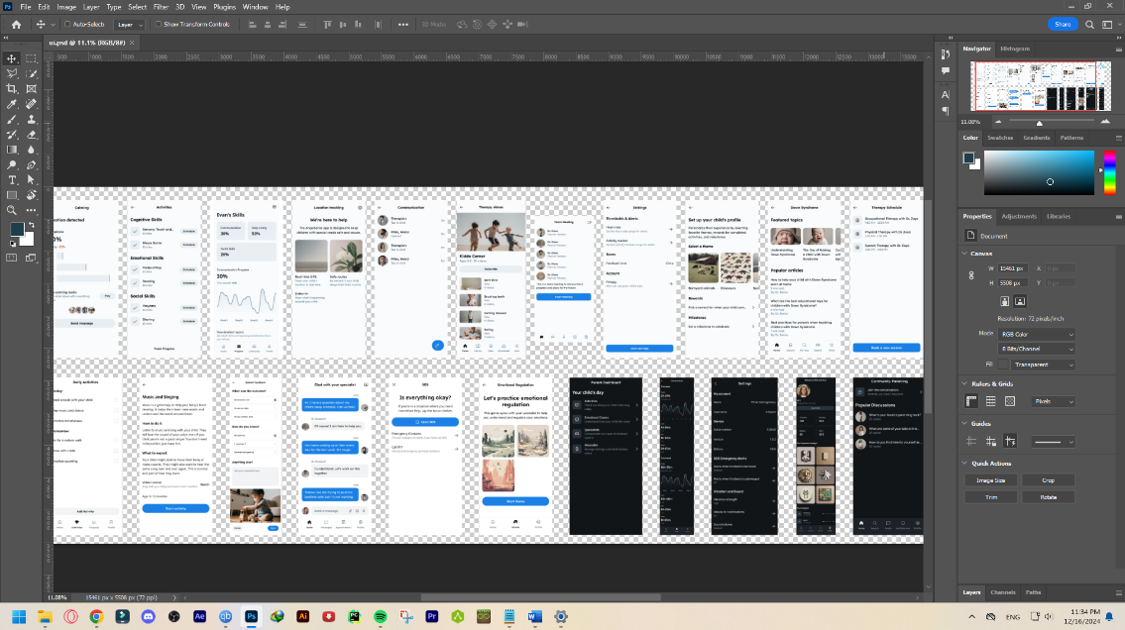 Specialist Dashboard: Allows therapists to view child progress, suggest activities, and communicate with parents

Figure 8 Multiple Screens' Designs

.**f. Workflow Design**

The system workflow follows these steps:

* **The wearable gadget** collects emotional data and sends it to the mobile app.
* **The app** analyzes the data and provides immediate feedback (e.g., calming sounds, prompts).
* **Parents** track the emotional state and progress through the app.
* **Specialists** review reports, recommend activities, and communicate with parents.

**g. Database Design**

The database stores all user and emotional data, therapy progress, and interaction logs. The data schema includes tables for users (parents, children, specialists), emotional states, activities, and feedback history.

**Diagram:**

* **Tables**: Users, Emotions, Progress Reports, Activities, Feedback.
* **Relationships**: Parents are linked to children; specialists are linked to activity suggestions and feedback.

**h. Design Constraints**

* **Hardware Limitations**: The wearable gadget is limited by battery life and sensor accuracy.
* **Budget Restrictions**: The design was optimized for cost-effective components without sacrificing essential features.

**i. Rationale for Design Choices**

* **Performance**: The iterative design ensures a user-friendly experience and efficient use of resources.
* **Scalability**: The system is designed to accommodate future updates and expansion, including support for additional therapists or devices.
* **Cost-effectiveness**: Using cost-efficient AI sensors and open-source frameworks for the app ensures a balance between quality and budget.
* **User Requirements**: The design prioritizes ease of use for parents, the ability for therapists to track progress, and the child’s interaction with real-time feedback